EXPT NO: 5 | IMPLEMENTATION OF A RECURRENT NEURAL NETWORK (RNN) FOR TEXT GENERATION
DATE: 24.08.2026

PRE-LAB QUESTIONS (PROVIDE BRIEF ANSWERS TO THE FOLLOWING QUESTIONS)

- Explain the purpose of a Recurrent Neural Network (RNN) in processing sequential data.
The primary purpose of a Recurrent Neural Network (RNN) in processing sequential data is to maintain and utilize context from previous inputs to inform the processing of current and future inputs. Unlike traditional feedforward neural networks that treat all inputs as entirely independent from one another, RNNs contain internal loops or "memory" that allow information to persist across time steps. This unique architecture makes them exceptionally well-suited for tasks where the order and context of the data are crucial, such as time series analysis, speech recognition, and natural language processing, ensuring that sequential dependencies are captured effectively.

- Why is an RNN considered an appropriate model for text generation tasks?
An RNN is considered highly appropriate for text generation tasks because human language is inherently sequential, meaning that the meaning of a word heavily depends on the words that came immediately before it. By leveraging its internal memory mechanism, an RNN can keep track of grammatical structures, context, and semantic meaning from previously generated or inputted words. When tasked with predicting the next word in a sentence, the RNN uses this accumulated contextual history rather than just looking at a single isolated word, allowing it to generate text that is significantly more coherent, contextually relevant, and grammatically structured.

- Describe the concept of sequence modeling in natural language processing.
Sequence modeling in natural language processing refers to the algorithmic approach of processing and analyzing data where the sequence or order of elements carries essential meaning, such as words in a sentence or characters in a word. The core concept revolves around mapping input sequences to output sequences while learning the temporal dynamics and structural dependencies embedded within the language data. In practice, sequence modeling involves training models to understand the probabilities of certain words following others, enabling tasks like machine translation, sentiment analysis, speech-to-text, and automated text generation by successfully anticipating what comes next.

- Explain the importance of tokenization during text preprocessing for RNN-based text generation.
Tokenization is a critical initial step in text preprocessing for RNN-based text generation because it breaks down unstructured, continuous text into smaller, manageable units called tokens, which can be characters, sub-words, or entire words. Neural networks cannot directly process raw, unformatted string data; they require a structured, segmented format to begin identifying patterns. By tokenizing the text, we establish a standardized vocabulary that the model can learn from. This structural breakdown allows the algorithm to analyze the frequency, relationships, and contextual usage of individual tokens, forming the necessary foundation for mapping these discrete units into numerical representations for the network.

- Explain the significance of converting text into numerical representations before training an RNN.
Converting text into numerical representations is of paramount significance before training a Recurrent Neural Network because machine learning models inherently operate using mathematical computations and cannot interpret raw textual characters or string variables. By mapping words or tokens to unique integer indices and subsequently transforming them into dense vectors, often through embedding layers, we translate linguistic concepts into a multidimensional geometric space. This numerical translation allows the network to mathematically calculate the distances, relationships, and semantic similarities between different words, thereby enabling the optimization algorithms to adjust weights and biases effectively to minimize errors during the training process.

AIM
To implement a Recurrent Neural Network (RNN) for text generation and evaluate its ability to generate meaningful text by predicting the next word in a sequence.

SOFTWARE REQUIREMENTS
- Python
- TensorFlow or keras or PyTorch
- Google Colab
- GitHub
- Numpy
- Matplotlib

OBJECTIVES
Students will be able to:
- Understand the architecture and working of Recurrent Neural Networks (RNNs).
- Perform text preprocessing techniques for sequence modeling.
- Generate input sequences suitable for training an RNN model.
- Build and train an RNN model for text generation.
- Generate text by predicting the next word in a sequence.
- Evaluate the performance of the trained RNN using generated text.
- Analyze the effectiveness of RNNs in learning sequential patterns from textual data.

PROCEDURE
PART A: DATASET PREPARATION
Perform the following tasks:
- Load the Tiny Shakespeare dataset from Hugging Face.
- Explore the dataset and examine the text samples.
- Convert the text into lowercase (if required).
- Tokenize the text into individual words.
- Build a vocabulary and assign a unique integer index to each word.
- Generate input sequences for next-word prediction.
- Apply sequence padding to obtain inputs of equal length.
- Split the prepared sequences into training and validation datasets.

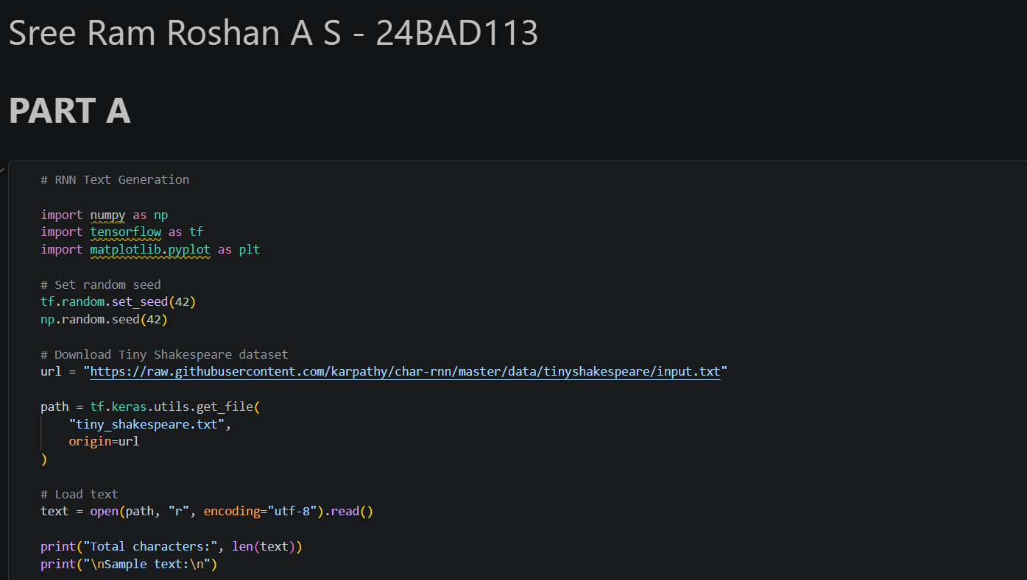
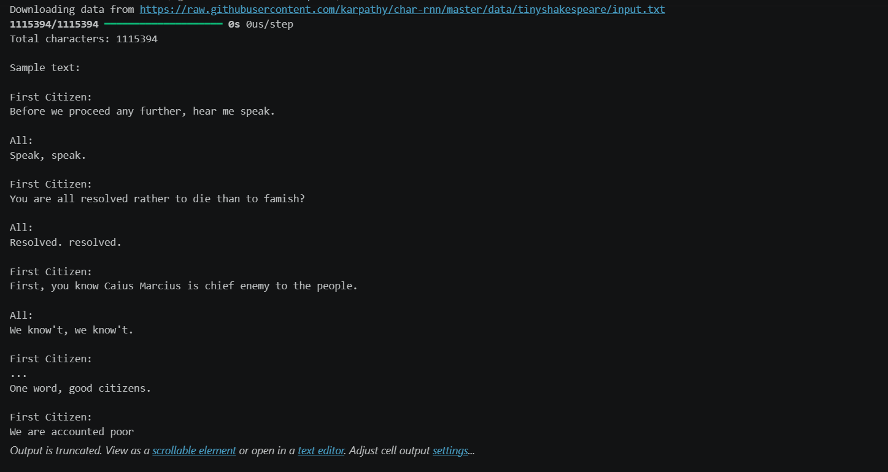
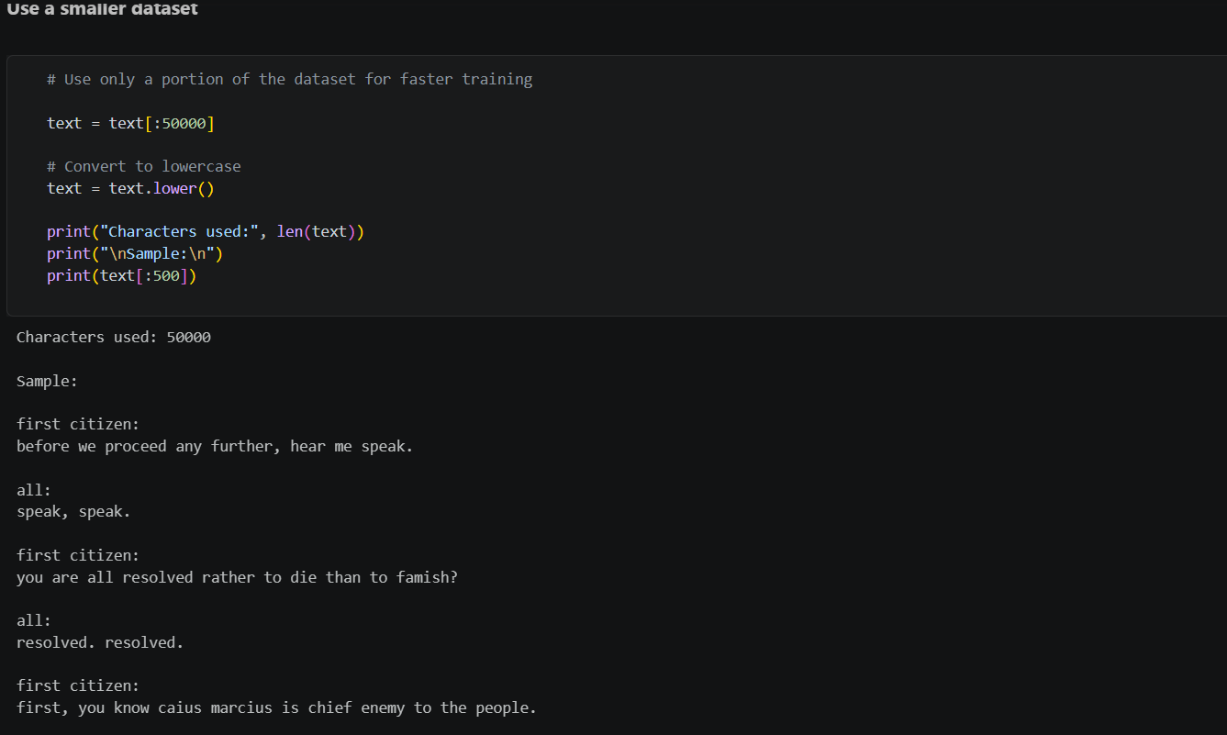
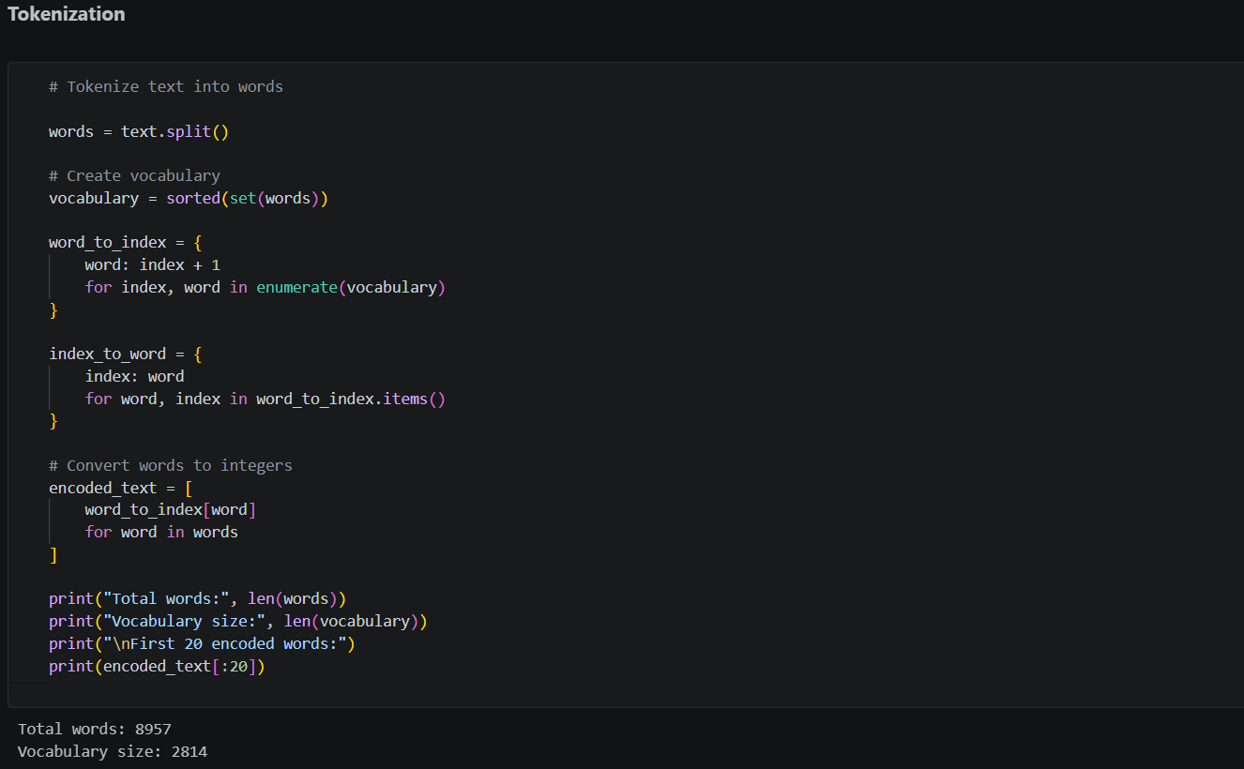
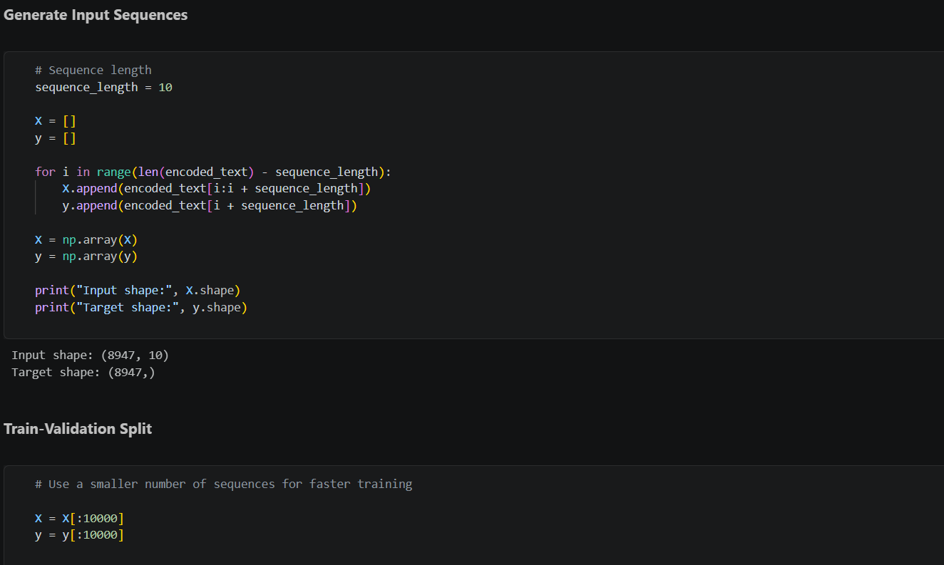
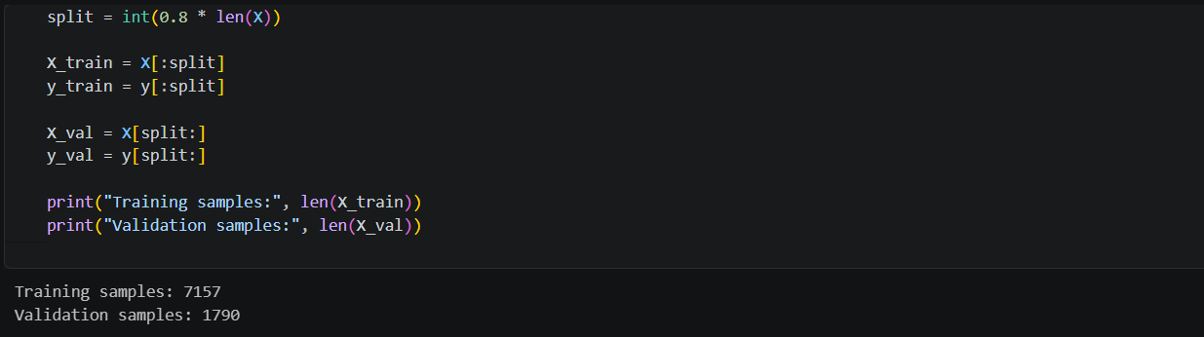

PART B: IMPLEMENTING THE RNN MODEL
Perform the following tasks:
- Create an Embedding layer to convert words into dense vector representations.
- Add a Simple RNN layer to learn sequential dependencies in the text.
- Add a Dense output layer with Softmax activation for next-word prediction.
- Compile the model using an appropriate optimizer and loss function.
- Display the model architecture and summary.

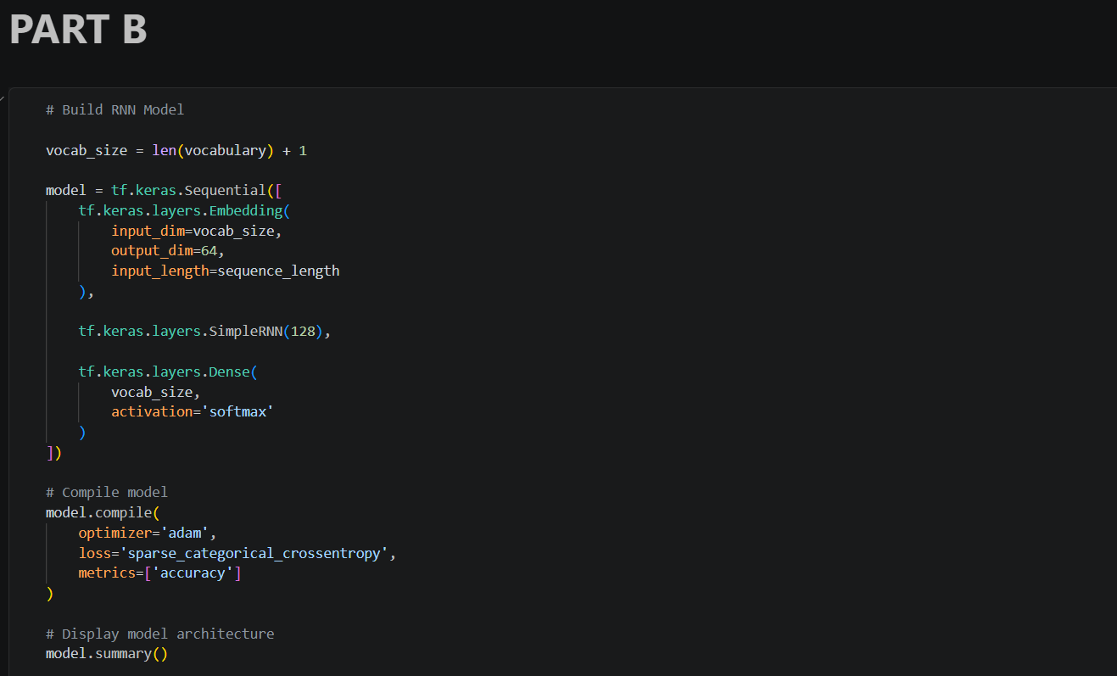
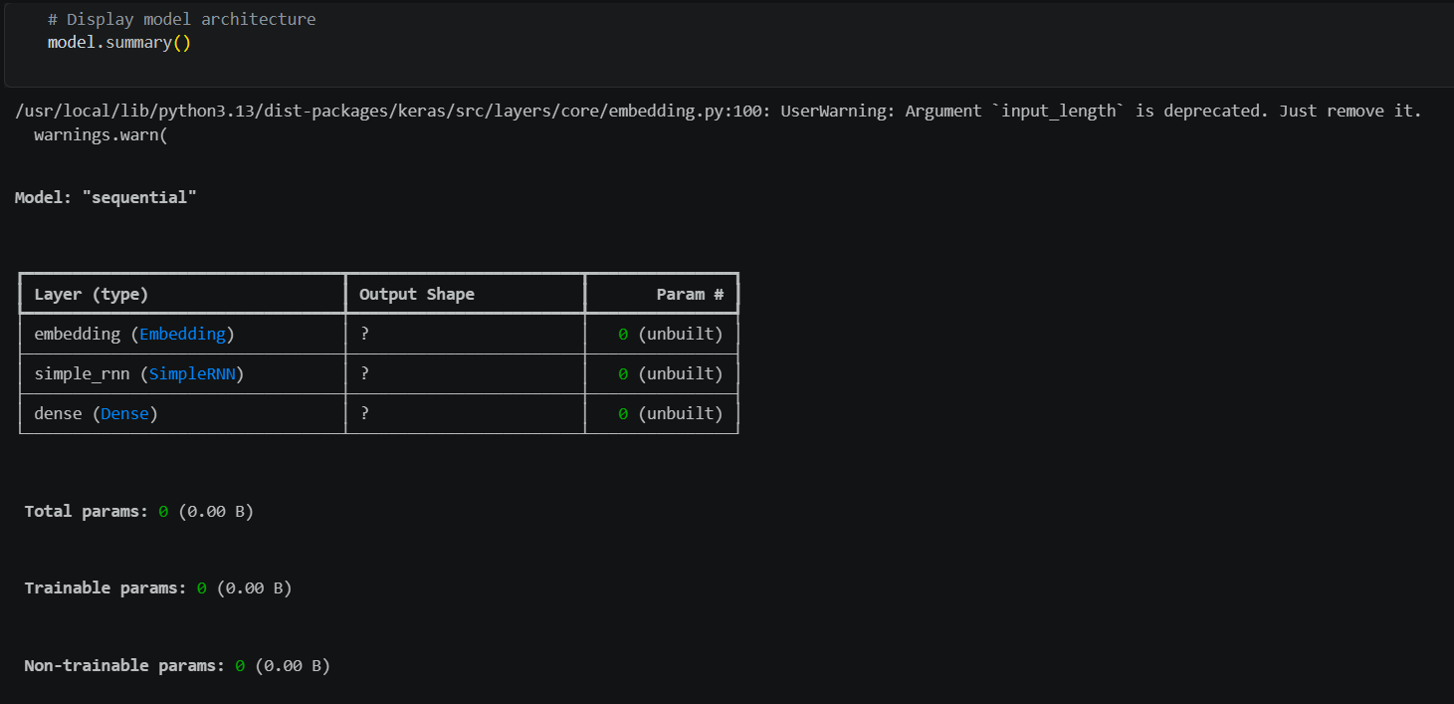

PART C: COMPARISON OF OPTIMIZATION ALGORITHMS
Perform the following tasks:
- Train the RNN model using the prepared training dataset.
- Validate the model using the validation dataset.
- Record:
  - Training accuracy
  - Validation accuracy
  - Training loss
  - Validation loss
- Visualize:
  - Accuracy vs. Epoch
  - Loss vs. Epoch

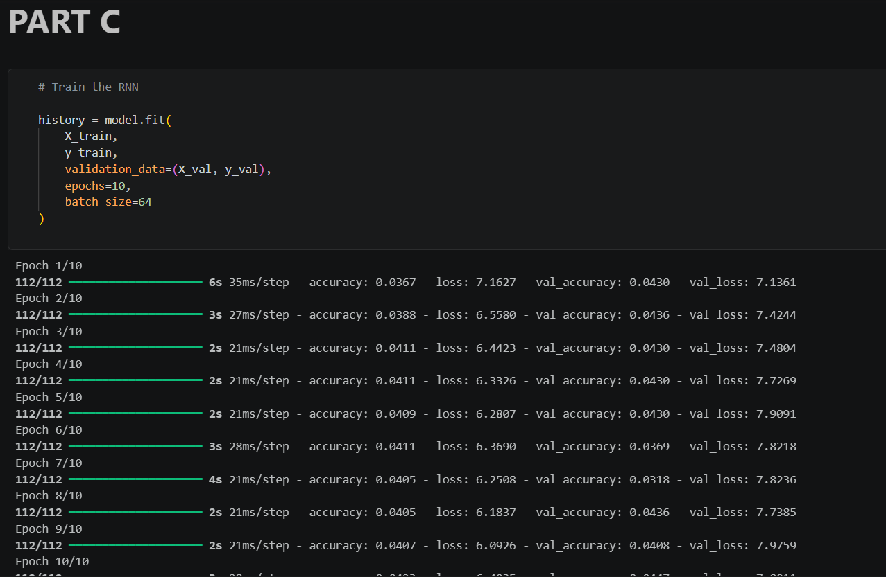
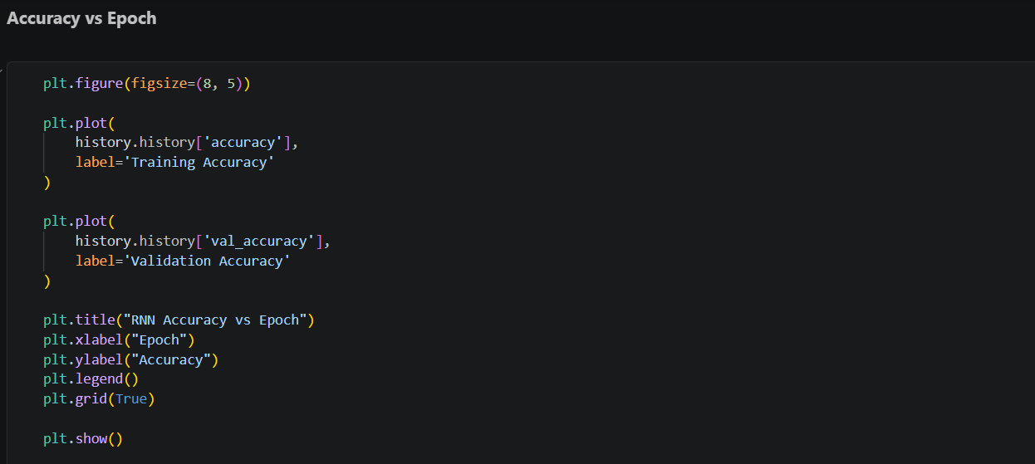
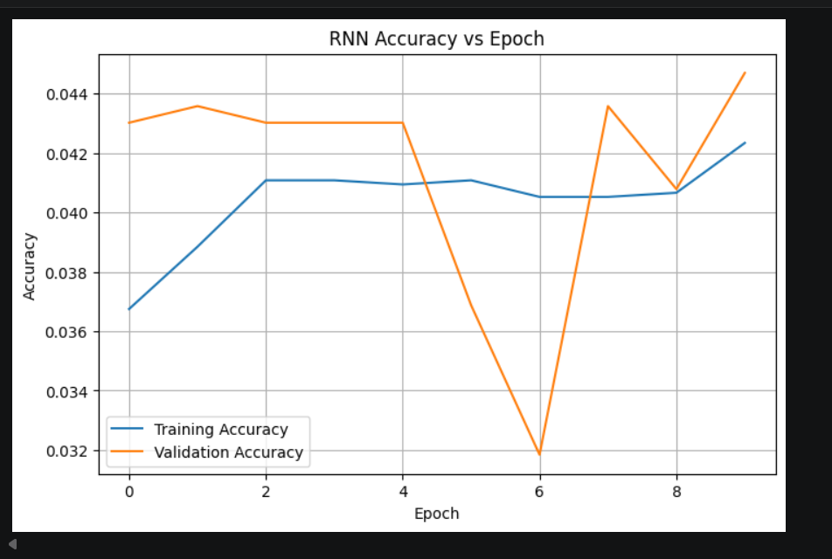
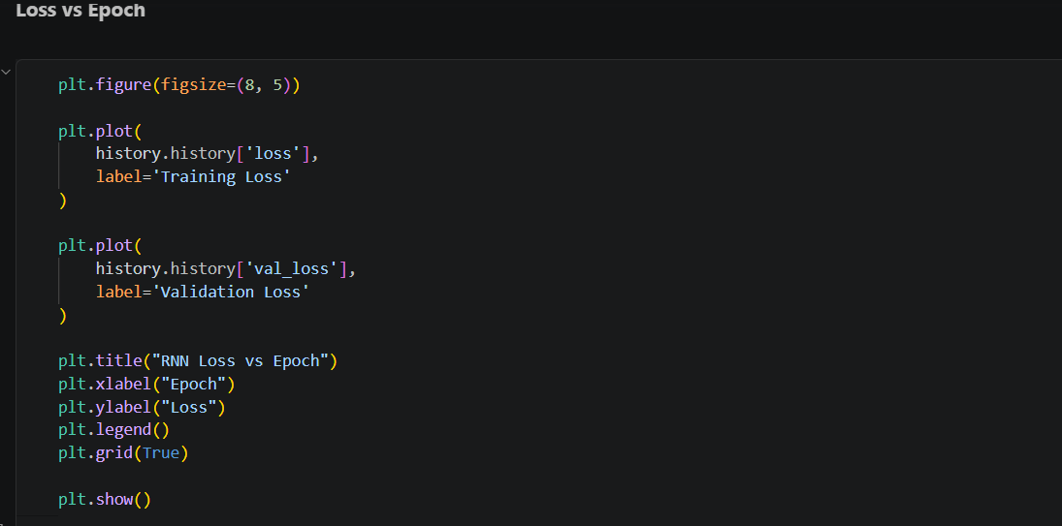
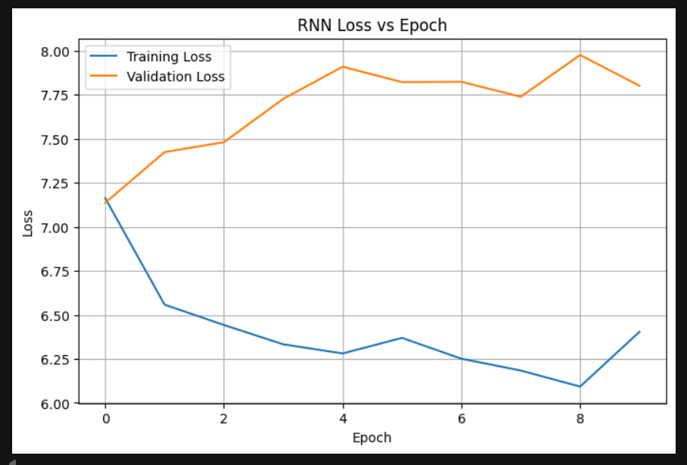

PART D: DEEP LEARNING EXPERIMENT MANAGEMENT
Perform the following tasks:
- Provide a seed word or sentence as input to the trained model.
- Generate text by repeatedly predicting the next word in the sequence.
- Produce multiple text samples using different seed inputs.
- Compare the generated text for coherence and contextual relevance.
- Document the observations and upload the notebook to GitHub.

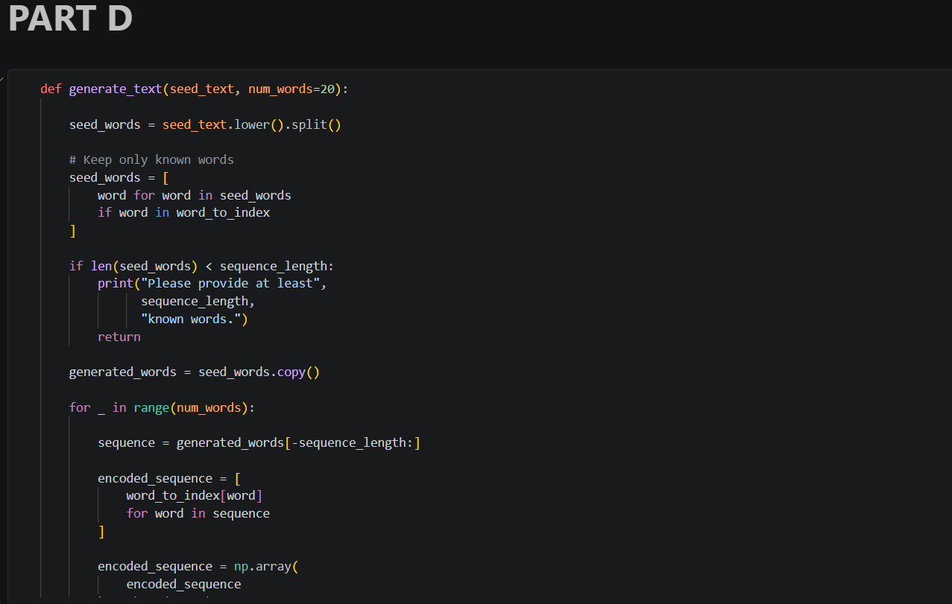

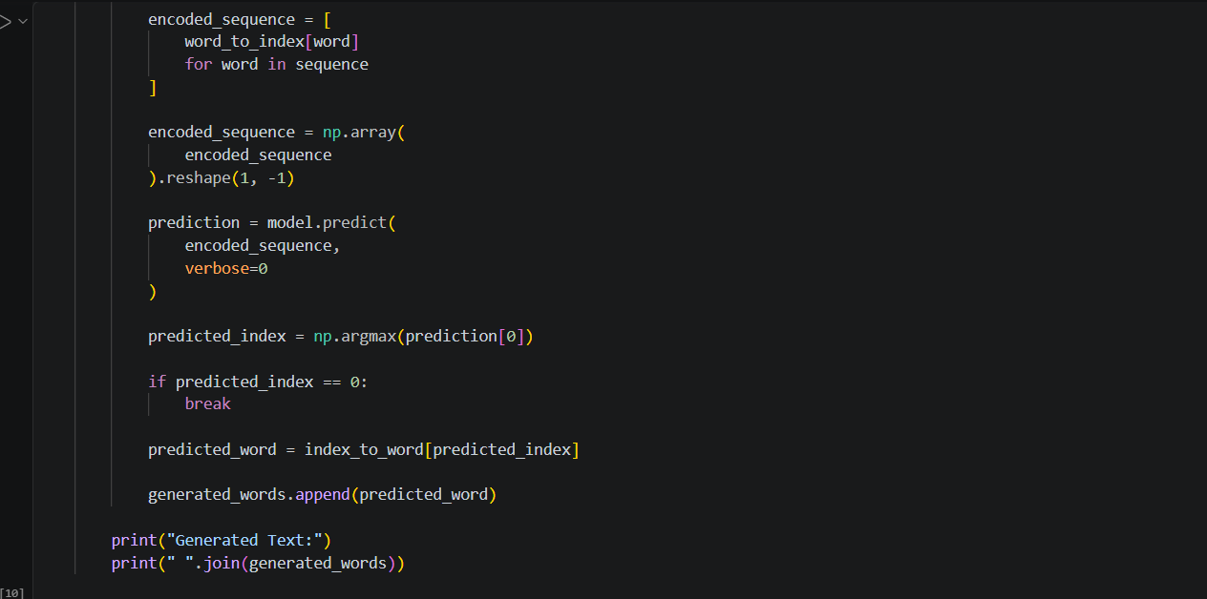
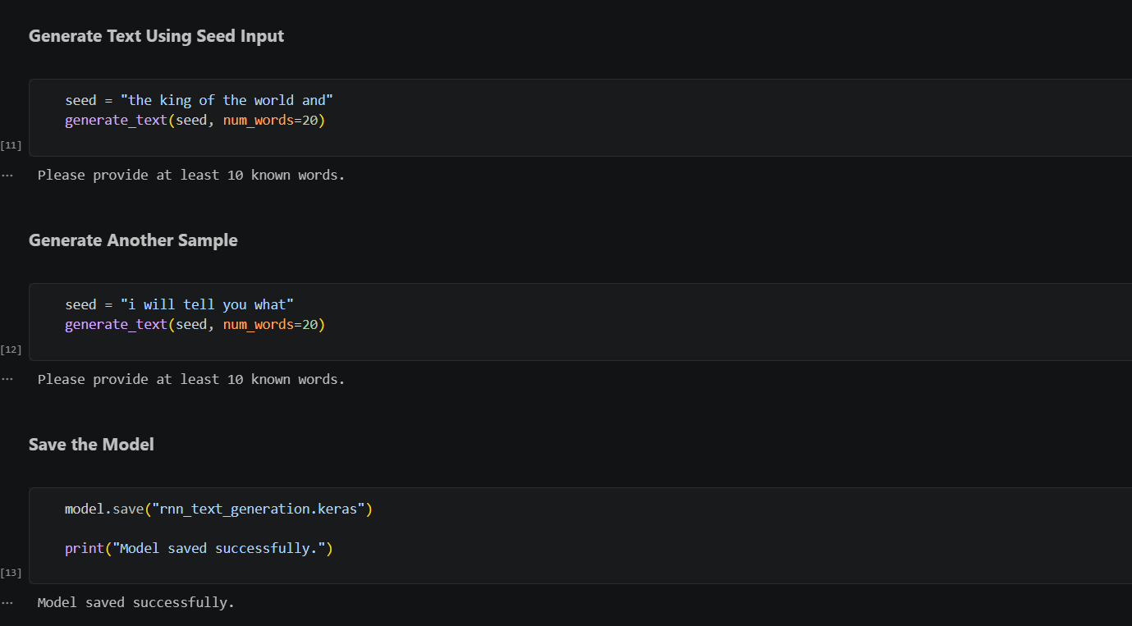
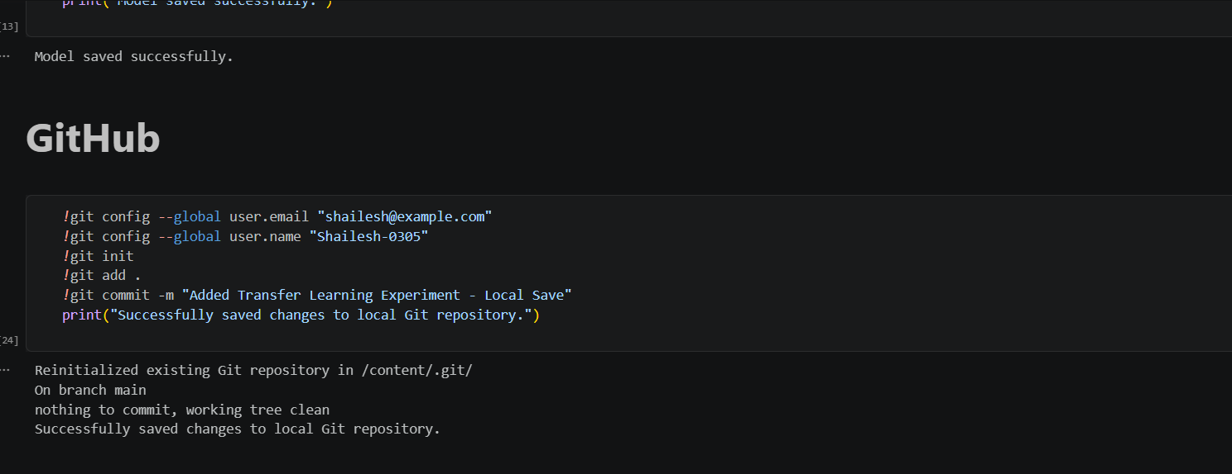

EXPECTED OUTCOME
Students will understand how an RNN learns sequential information and generates meaningful text based on previously learned patterns. Students will learn to preprocess textual data and train a Recurrent Neural Network (RNN) for text generation. They will evaluate the model's performance using training metrics and generate text through next-word prediction.

POST-LAB QUESTIONS (PROVIDE BRIEF ANSWERS TO THE FOLLOWING QUESTIONS)

- Describe the role of the hidden state in an RNN during sequence processing.
The hidden state in a Recurrent Neural Network acts as the network's internal working memory during sequence processing, serving as a dynamic mechanism to carry information across different time steps. As the RNN processes each element in a sequence, it updates the hidden state by combining the current input with the hidden state from the immediately preceding time step. This continuous updating process allows the hidden state to encapsulate a summary or representation of all the historical information the network has observed up to that specific point. Consequently, this context heavily influences the model's output and predictions at the current step.

- Discuss the effect of training an RNN model for an insufficient number of epochs.
Training an RNN model for an insufficient number of epochs generally leads to a phenomenon known as underfitting, where the model has not had enough exposure to the training data to learn the underlying sequential patterns and relationships adequately. In the context of text generation, this premature cessation of training typically results in high training and validation losses, as the network's internal weights have not been sufficiently optimized. Consequently, the text generated by such an under-trained model is often nonsensical, repetitive, and lacks coherent grammatical structure, demonstrating a clear inability to accurately predict the next word or maintain contextual relevance.

- Explain the purpose of padding when preparing text sequences for RNN training.
The primary purpose of padding when preparing text sequences for RNN training is to ensure uniform input dimensions, which is a strict requirement for processing data in batches within modern deep learning frameworks. Natural language data inherently consists of sentences or sequences of varying lengths; however, neural networks require matrices with fixed, consistent shapes to perform highly optimized matrix multiplications. By appending a specific dummy token, such as a zero, to the beginning or end of shorter sequences, padding effectively aligns all inputs to the length of the longest sequence in the batch without fundamentally altering the core meaning or the learned patterns.

- Discuss one limitation of a Simple RNN when processing long text sequences.
One significant limitation of a Simple Recurrent Neural Network when processing long text sequences is its extreme susceptibility to the vanishing gradient problem. As the network attempts to backpropagate errors across many time steps during training, the gradients—which are used to update the network's weights—are repeatedly multiplied by values that are often less than one. This causes the gradients to shrink exponentially, eventually "vanishing" or becoming too small to make meaningful adjustments to the weights of earlier layers. As a direct result, Simple RNNs struggle severely to retain and connect long-term dependencies, failing to remember context from the distant past.

- Discuss the effect of sequence length on the performance of the text generation model.
The chosen sequence length has a profound effect on the performance and capabilities of a text generation model. If the sequence length is set too short, the model lacks sufficient historical context to make accurate predictions, resulting in generated text that may be grammatically correct locally but lacks overarching coherence or thematic consistency. Conversely, utilizing excessively long sequence lengths can significantly increase the computational burden and memory requirements during training. Furthermore, very long sequences may exacerbate vanishing gradient issues in standard RNN architectures, making it difficult for the model to effectively learn the most relevant patterns amidst a large window of distant noise.

ASSESSMENT
Description | Max Marks | Marks Awarded
Pre Lab Exercise | 5
In Lab Exercise | 10
Post Lab Exercise | 5
Viva | 10
Total | 30
Faculty Signature

